**A**

**Project Report**

**on**

**Non-Fungible Token (NFT)**

**In partial fulfillment of Post Graduate course**

**in**

**Master of Science (Computer Applications) – I**

**(Semester -II)**

**CSA4212 Computer Applications Project - I**

**Submitted By**

**Aditya Narendra Bachal (Roll No. – 21572)**

**Department of Computer Science**

**Fergusson College (Autonomous), Pune-411004**



**Deccan Education Society’s**

**Fergusson College (Autonomous), Pune**

**Department of Computer Science**

(CSA4212) Computer Science Project-II

**CERTIFICATE**

This is to certify that **Mr. Aditya Narendra Bachal** Roll No. 21572 has satisfactorily completed the project work entitled **“Non – Fungible Token (NFT)”** towards the partial fulfillment of M.Sc. (Computer Application), Semester II during the academic year 2021-22.

**Place**: Pune

**Date**: / /2022

**Mrs. Talluri SreeLalitha Dr. Kavita A. Khobragade**

Internal Guide **Head, Computer Science Department**

**Internal Examiner External Examiner**

**Index**

|  |  |  |
| --- | --- | --- |
| **Sr. No.** | **Table of Content** | **Page No.** |
| **1** | **Introduction** | **1** |
| 1. Existing System | **1** |
| 1. Need of the System | **1** |
| 1. Overview of the Project | **2** |
| **2** | **Analysis** | **3** |
| 2.1 Feasibility Study | **3** |
| 2.1.1 Technical feasibility | **3** |
| 2.1.2 Economical Feasibility | **3** |
| 2.1.3 Operational feasibility | **3** |
| 2.2 Hardware and Software requirements | **4** |
| **3** | **Design** | **5** |
| 3.1 Flow Chart | **5** |
| 3.2 Input / Output Screens | **6** |
| **4** | **Testing** | **9** |
| 4.1 Importance of testing | **9** |
| 4.2 Types of testing | **9** |
| 4.3 Test cases | **10** |
| **5** | **Reports** | **11** |
| **6** | **Drawbacks and limitations** | **12** |
| **7** | **Future enhancement and conclusion** | **13** |
|  | 7.1 Future enhancement | **13** |
|  | 7.2 Conclusion | **13** |
| **8** | **Bibliography** | **14** |

**1. Introduction**

* 1. **Existing System**

A digital asset that reflects real-world elements like art, music, in-game goods, and movies is known as Non-Fungible Token (NFT). NFTs are generated and stored on the Ethereum network. The primary benefit of Non-Fungible Tokens is the ability to prove ownership. NFTs can assist in linking ownership to a single account because they are on a blockchain network. Minting fees are high, so the buyer must pay more to cover the costs.  The Physical money and cryptocurrencies are “fungible,” therefore, they can be traded or exchanged for one another. In the existing system, the current meta is new to the entire world, the user interface is not easy to use for all age groups (especially to people of Generation X and Millennials).

* 1. **Need of System**

Non-Fungible Token (NFT) allows the buyer to own the original item. It contains built-in authentication, which affects the proof of ownership. Collectors value those “digital bragging rights” almost more than the item itself. For the transaction purpose of Non-Fungible Token (NFT), the user requires crypto wallet and then availability of trading platform. This crypto wallet and platform have multiple flaws such as cryptography, access to the local storage, lack of authentication, lack of input validation and security flaws etc. For the transaction to be carried out between the two parties, there must be a centralized legal crypto coin, which will be legitimate and trustful platform where NFTs can be traded with maximum safety.

* 1. **Overview of the Project**

The Non-Fungible Token (NFT) marketplace is a platform that stores digital assets in secure virtual vault. The minting of NFTs which will give the user privilege to create their own collection and make available to the world. In the proposed system, when user visit the website all the assets are visible where user can buy or sell them as per the condition. The transactions of NFTs take place with the help of Meta Mask wallet which is the safest and most secured wallet to maintain privacy of the users. Cryptocurrencies leverage blockchain technology to gain decentralization, transparency, and immutability. The proposed system consists of 5 modules and their functionalities are as follows:

1. **Hosting platforms for NFTs (Non-Fungible Tokens) to generate blockchains**

This module helps to buy and sell NFT which is an ideal place for storing digital assets

securely which are unique, collectible.

1. **Crypto wallet for Decentralized website**

This module helps to store and manage account keys, broadcast transactions, send and receive cryptocurrencies and tokens securely.

1. **Legalized Cryptocurrency Coin for transactions**

This module helps to use unique cryptocurrency which is a virtual or digital currency that can be used to buy goods and for trading services.

1. **Blockchain security**

This module helps to protect a blockchain solution from online frauds, breaches, and other cyberattacks.

1. **Hashing method of cryptography that converts any form of data into a unique string.**

This module helps in hashing algorithm that takes an arbitrary amount of data input i.e., a credential and produces a fixed-size output of encrypted text called a hash value.

**2. Analysis**

**2.1 Feasibility Study**

**2.1.1 Technical feasibility**

The proposed system as a website is developed using the existing open-source technologies and open-source libraries available in python. The application can be accessed through available internet web browsers to identify potential safety and environmental hazards and can be used to conduct a preliminary production feasibility, manufacturing assessments also to estimate hosting prototype. Hence the system is technically feasible.

* + 1. **Economic Feasibility**

The proposed system is developed using different open source softwares which are available for free of cost. The designed web app can be viewed on Google Chrome as meta mask component is to be used, there is no extra additional cost charged to the user. Hence it is economically feasible.

**2.1.3 Operational feasibility**

The user can be educated with basics of this technology and computers which will be enough to operate on this network. The Platform is being developed in compatibility of the existing and software set up. Hence it is operationally feasible.

**2.2 Hardware and Software requirements**

**2.2.1 Hardware Requirements**

1. SSD – 500mb.
2. 64-bit Operating System
3. RAM – 512mb (Intel, raspberry pi (512MB))
4. System – Desktop, laptop, android > 1GHz
5. Processor – Intel i3, i5, i7 and above
   * 1. **Software Requirements**

**Web technologies:** HTML, CSS, JavaScript, React JS

**Programming Languages:**

* Python (Frameworks and Libraries)
* Flask (Micro web framework written in Python)

**Development:** Solidity

**Operating System:** Windows 10/11

**3. Design**

**3.1 Flow Diagram**

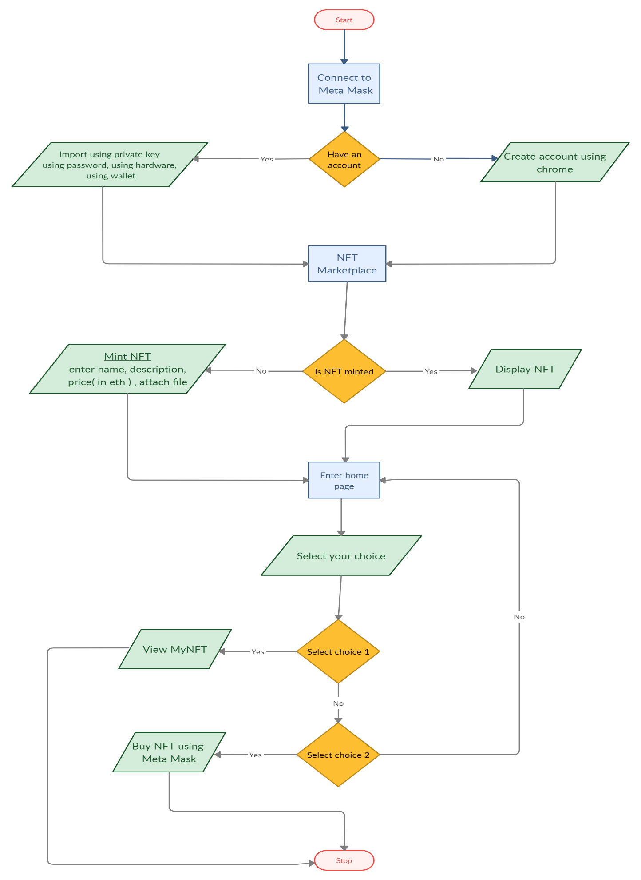

**3.2 Input / Output Screens**

**Minting an NFT**

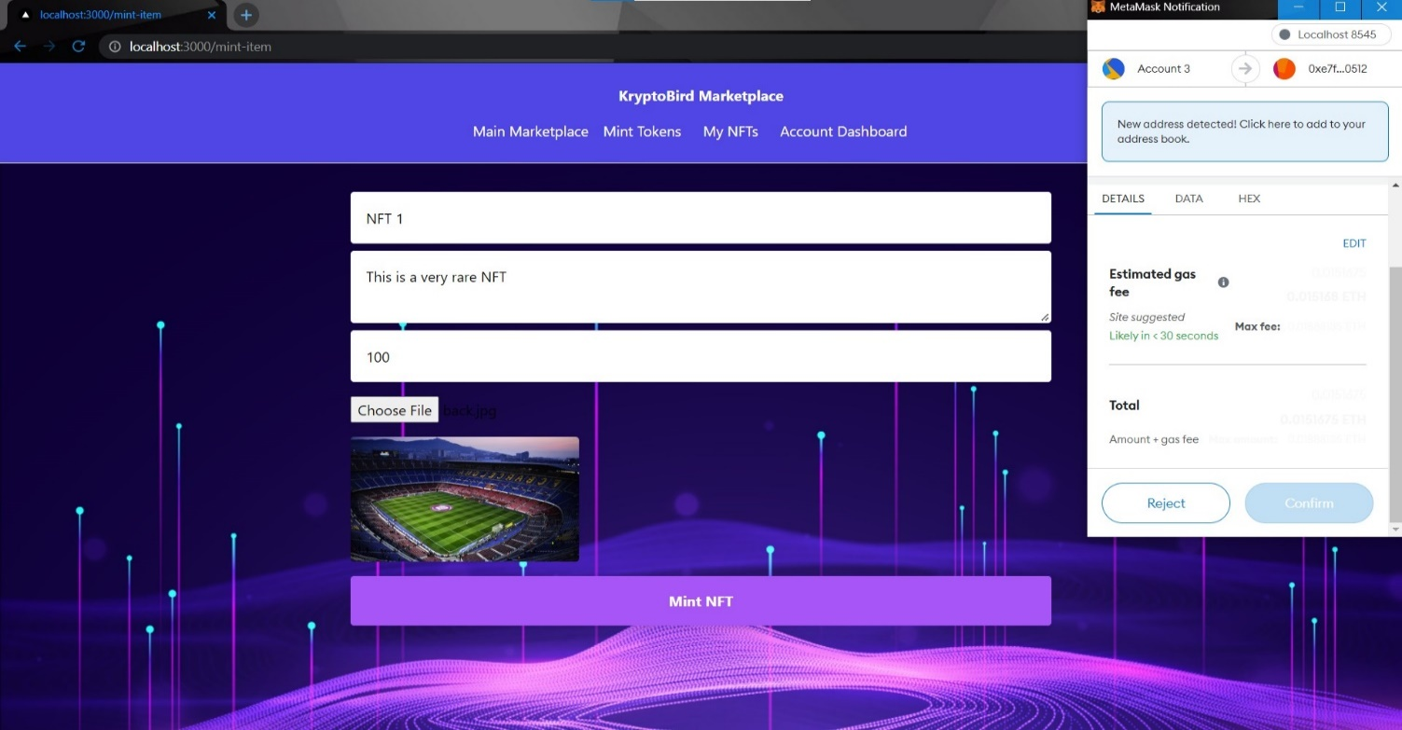

**Deployed Minted token**

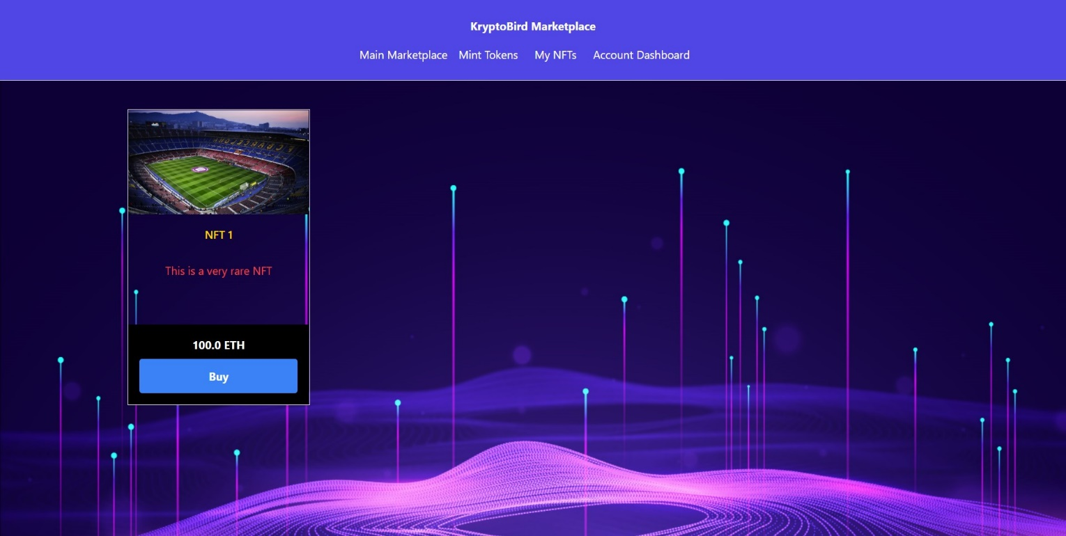

**Buying an NFT**

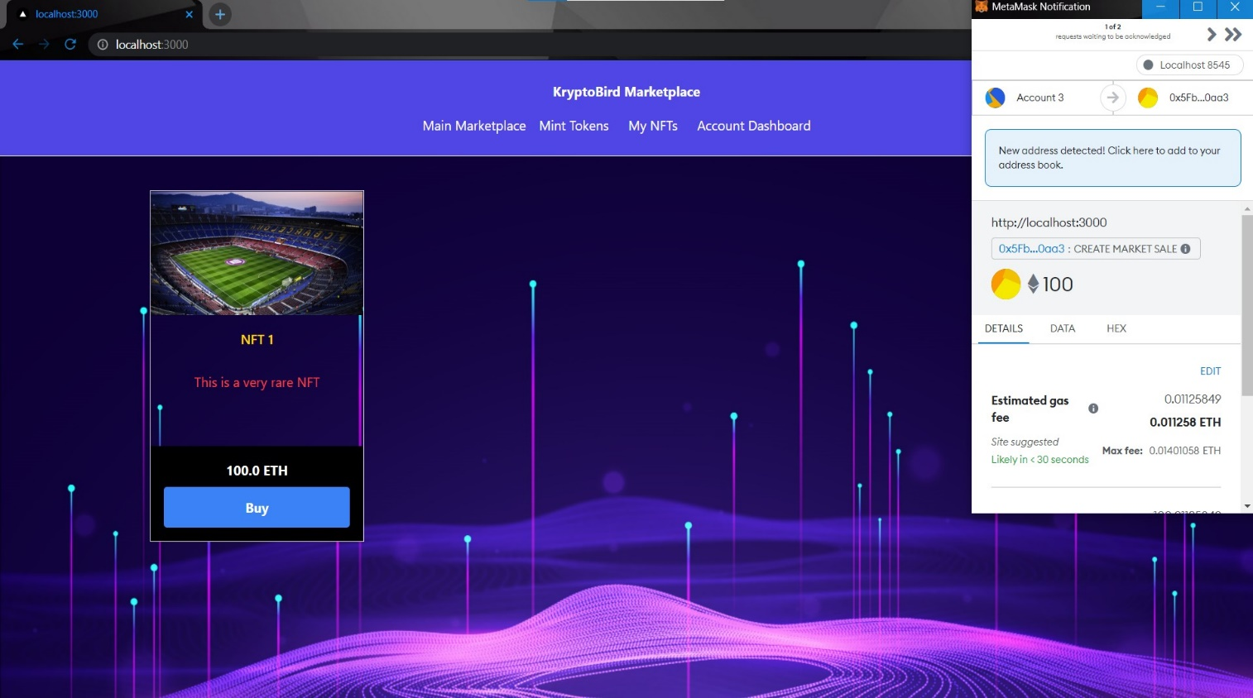

**Meta Mask transaction**

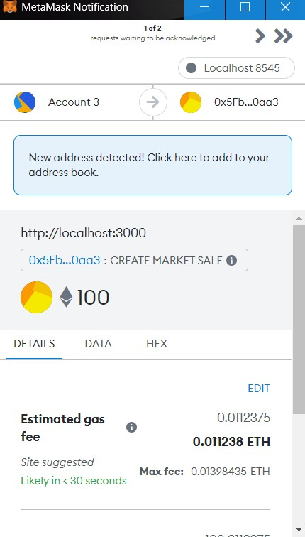

**NFT in My NFTs**

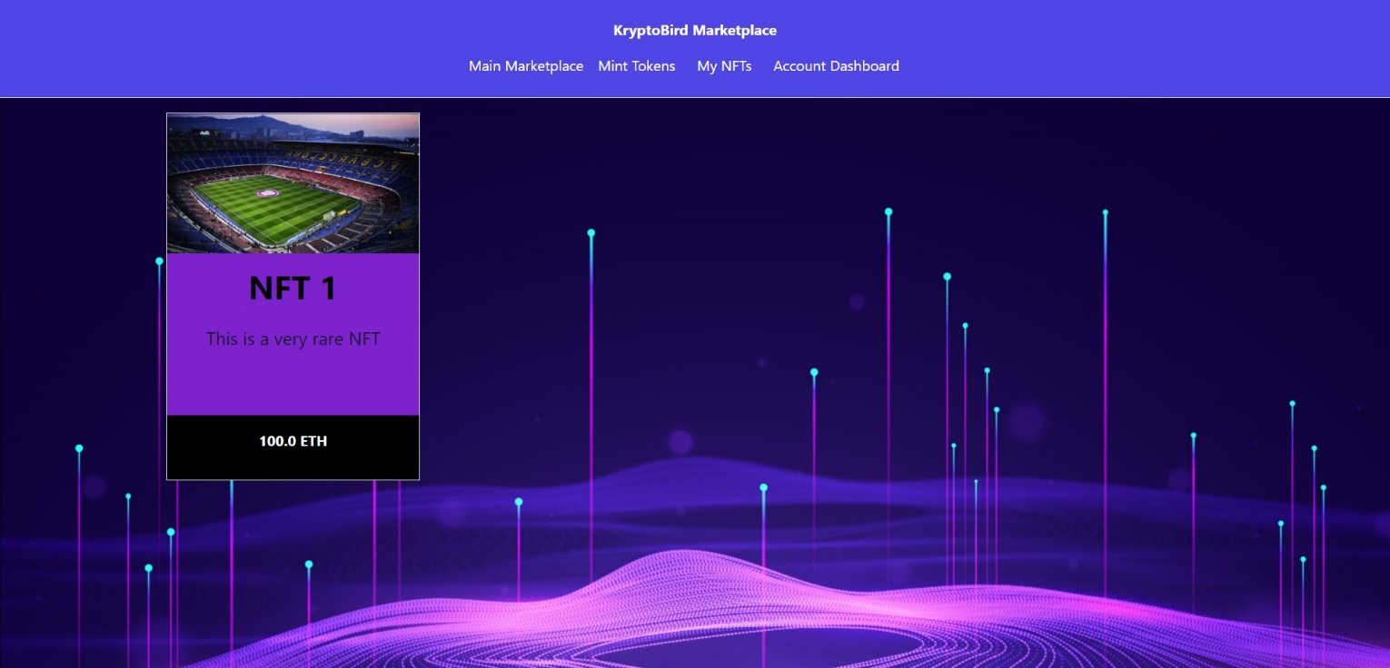

**User minted NFT**

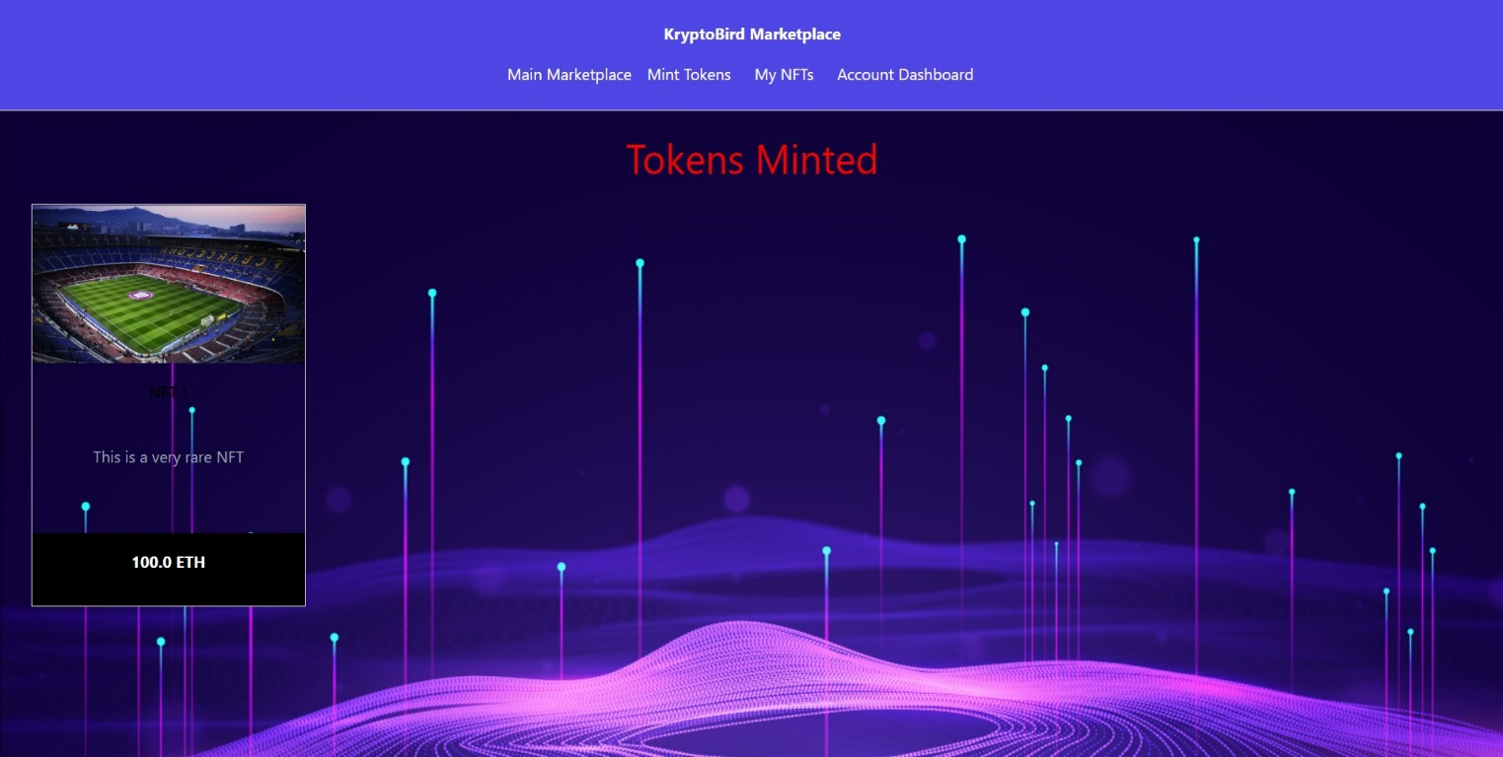

**4. Testing**

**4.1 Importance of testing**

In projects, testing is a way to make sure that the requirements under a project are fulfilled accurately and it is free from manual errors, system environment issues, coding issues, crashes, performance, security etc. The testing is important since it discovers defects/bugs before the delivery to the client, which guarantees the quality of the software. Testing also helps to make our product better by knowing and understanding. It makes the system reliable and ensures a good performance of the system. It also gives best user experience, usability, and security.

**4.2 Types of testing**

**Unit testing**

Unit testing tests every individual module in which all the testable parts are run independently and performs the required tests. It was carried out to validate that each unit of the software code performs as expected. Unit Tests isolate a section of code and verify its correctness.

**Validation testing**

Validation testing gives the confirmation that product meets its intended use and the needs of its users. It was carried out to confirm that all functional and performance specifications were satisfied or not by presenting the result after test is carried out.

**System testing**

System Testing validates the complete and fully integrated product. It was carried out to evaluate the end-to-end system specifications.

**4.3 Test cases**

|  |  |  |  |  |  |
| --- | --- | --- | --- | --- | --- |
| **Test case ID** | **Feature** | **Description** | **Steps to execute** | **Expected Results** | **Pass/**  **Fail** |
| TC001 | Contract deployment. | Contract address gets deployed through blockchain technology | Connecting to hardhat | A successful deployment of contract should be shown in cmd. | Pass |
| TC002 | Setting up metamask. | Importing account in metamask wallet. | 1) Enter wallet key address on the respective fields  2) Click on import | User should be able to view account balance. | Pass |
| TC003 | Mint NFT. | NFT gets deployed on main marketplace. | 1) Enter Token ID, Name, Description, Price.  2) Click on Mint NFT. | User will be able to host NFT on the main marketplace. | Pass |
| TC004 | Buy NFT. | Bought NFT will be visible in My NFT section. | 1) Select the desired NFT and make payment through metamask.  2) Click on buy. | User will be directed to Metamask where user must pay the amount of that item in order to buy it. | Pass |

**5. Reports**

**Functional report for Hash Algorithm**

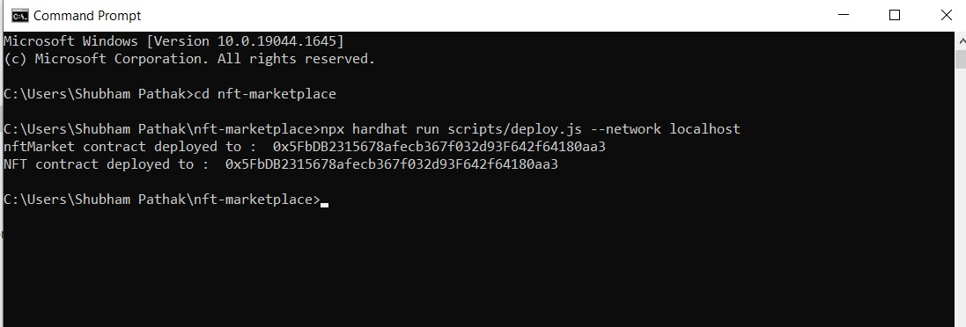

**Analytical report for Block chain**

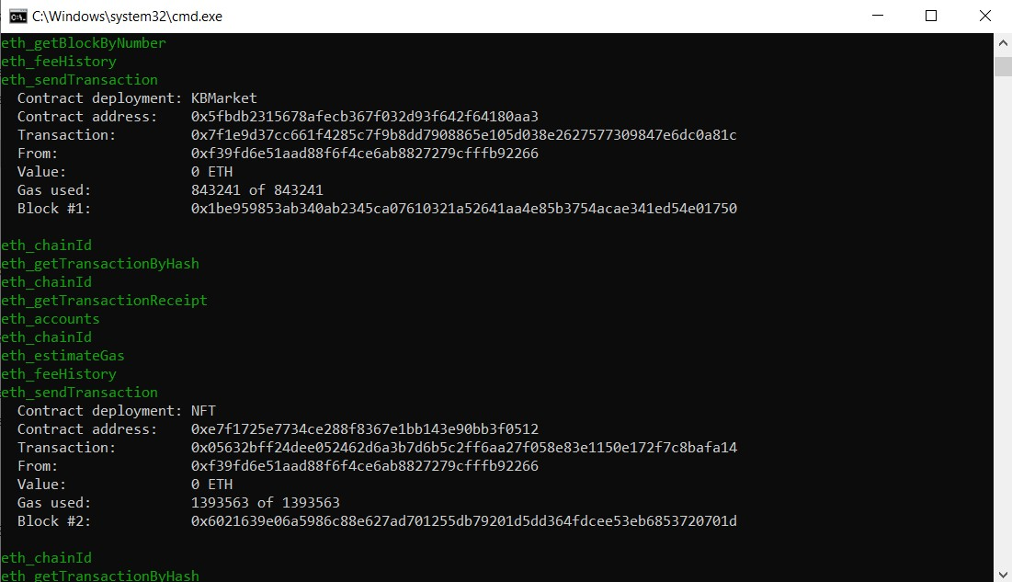

**6. Drawbacks and Limitations**

The process of storing of data and information in the proposed system is performed locally as maintaining

a database requires cost and other expensive software’s.

Determining the price of a NFT can be confusing, expert advice can be sought for this purpose to avoid

wrong investment in this extremely expensive digital asset. Transactions which are made through

developed crypto coin (SIUUU) are not real, it takes place through dummy currency and not real one.

Legalizing a crypto coin requires mining and monetization: The risks of trading cryptocurrencies are mainly related to its volatility. They are of very high-risk and speculative.

Copies of Digital Assets Are Possible: The important thing is that an individual who possesses the NFT of a digital object does not rule out the possibility of copies.

NFTs Do Not Generate Income**:** Unlike dividend-paying stocks, interest-bearing bonds, and rent-generating real estate, NFTs do not offer their owners any income potential. Platform errors are generated as an extended period is used to create a digital work of art, which means that the platforms become complicated and generate errors.

**7. Future enhancement and Conclusion**

**7.1 Future Enhancement**

A legalized coin is used for the transactions to be carried out in the proposed system which consists of Meta Mask wallet and Ethereum (which is a well-established and legalized coin). To perform the transactions of buying and selling, the foresight is to carry out operations with the help of self-established crypto wallet and a cryptocurrency.

Thus, development of crypto coin named SIUUU has been initiated which works on the principle of blockchain. With the help of SIUUU coin, the user can execute transaction on developed wallet. The module challenges the lay figure of the coin.

Proposed system legalization to embrace new opportunities and launch to the real world should implement:

* Consensus mechanism
* Establish Blockchain platform
* Design the Nodes
* Structure of APIs
* Interface
* Documentation
* KYC verification

**7.2 Conclusion**

The range of possibilities is unlimited and diverse with the use of NFTs. Apart from game collectibles and works of digital art, non-fungible tokens have a tremendous capacity to represent virtual-world property items and even become game-changers in the sports and fashion industries. NFTs are undoubtedly one of the next big things in online commerce. Investing in tokenized assets is now accessible to everyone. Asset ownership that is tokenized into an NFT can now become more easily and efficiently be transferred among people anywhere in the world.

The system developed is user-friendly which tries to overcome all the problems where the commission is low. NFT market notes the arrival of many reputed brands in the NFT ecosystem. All the data is secured and verified, and all the transactions are safe and encrypted. Cryptocurrencies leverages blockchain technology to gain decentralization, transparency, and immutability.

**8. Bibliography**

1. Nader Dabit: Previously led Developer Advocacy for Front End Web and Mobile Web and building scalable full stack apps.
2. SHA-256: <https://www.movable-type.co.uk/scripts/sha256.html>
3. Tutorials point: Solidity.
4. <https://www.mindinventory.com/blog/how-to-build-an-nft-marketplace>[/](https://www.mindinventory.com/blog/how-to-build-an-nft-marketplace/)
5. React JS: <https://www.javatpoint.com/reactjs-tutorial>/
6. Hardhat (For test, compile, debug): <https://www.npmjs.com/package/hardhat>